Лепка: «Мой любимый сказочный герой»
https://yandex.ru/images/search?text=%D0%BB%D0%B5%D0%BF%D0%BA%D0%B0%20%D0%BC%D0%BE%D0%B9%20%D0%BB%D1%8E%D0%B1%D0%B8%D0%BC%D1%8B%D0%B9%20%D1%81%D0%BA%D0%B0%D0%B7%D0%BE%D1%87%D0%BD%D1%8B%D0%B9%20%D0%B3%D0%B5%D1%80%D0%BE%D0%B9%20%D0%BF%D0%BE%D0%B4%D0%B3%D0%BE%D1%82%D0%BE%D0%B2%D0%B8%D1%82%D0%B5%D0%BB%D1%8C%D0%BD%D0%B0%D1%8F%20%D0%B3%D1%80%D1%83%D0%BF%D0%BF%D0%B0&stype=image&lr=16&source=wiz

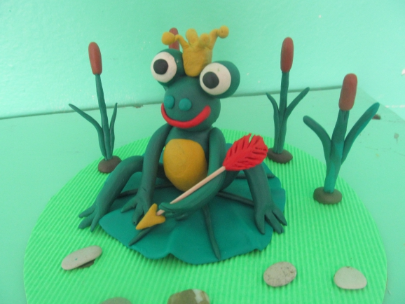

Рисование: «Обложка для книги»
https://yandex.ru/images/search?text=%D1%80%D0%B8%D1%81%D0%BE%D0%B2%D0%B0%D0%BD%D0%B8%D0%B5%20%D0%BE%D0%B1%D0%BB%D0%BE%D0%B6%D0%BA%D0%B0%20%D0%B4%D0%BB%D1%8F%20%D0%BA%D0%BD%D0%B8%D0%B3%D0%B8%20%D1%81%D0%BA%D0%B0%D0%B7%D0%BE%D0%BA%20%D0%B2%20%D0%BF%D0%BE%D0%B4%D0%B3%D0%BE%D1%82%D0%BE%D0%B2%D0%B8%D1%82%D0%B5%D0%BB%D1%8C%D0%BD%D0%BE%D0%B9%20%D0%B3%D1%80%D1%83%D0%BF%D0%BF%D0%B5&stype=image&lr=16&source=wiz

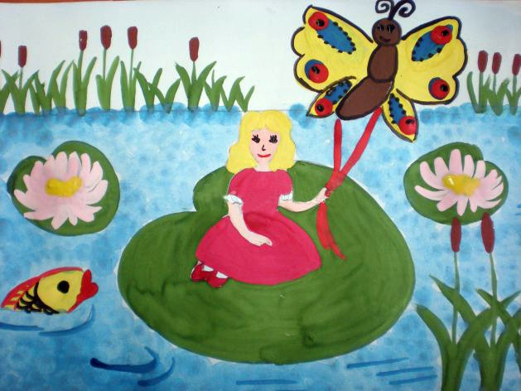

Аппликация: «Закладка для книг»
https://yandex.ru/images/search?text=%D0%B0%D0%BF%D0%BF%D0%BB%D0%B8%D0%BA%D0%B0%D1%86%D0%B8%D1%8F%20%D0%B7%D0%B0%D0%BA%D0%BB%D0%B0%D0%B4%D0%BA%D0%B0%20%D0%B4%D0%BB%D1%8F%20%D0%BA%D0%BD%D0%B8%D0%B3%20%D0%B2%20%D0%BF%D0%BE%D0%B4%D0%B3%D0%BE%D1%82%D0%BE%D0%B2%D0%B8%D1%82%D0%B5%D0%BB%D1%8C%D0%BD%D0%BE%D0%B9%20%D0%B3%D1%80%D1%83%D0%BF%D0%BF%D0%B5&stype=image&lr=16&source=wiz

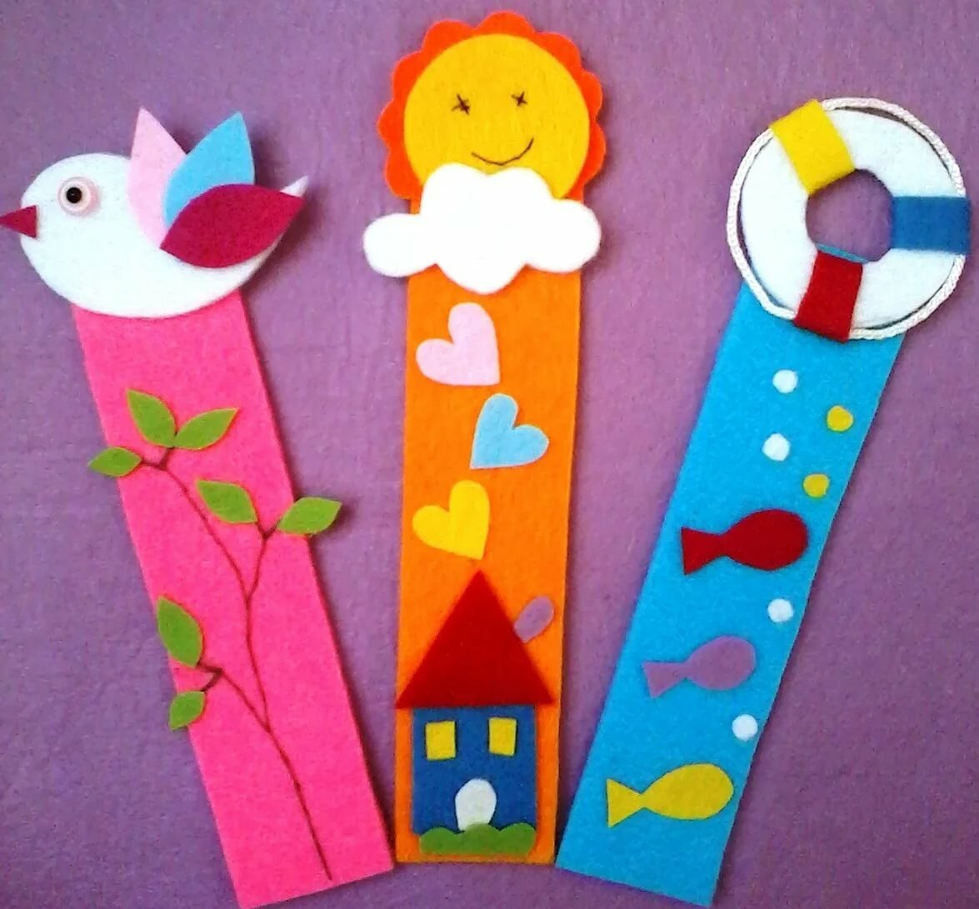

Изготовление книжек-самоделок для детей младшей группы.
https://yandex.ru/images/search?text=%D0%98%D0%B7%D0%B3%D0%BE%D1%82%D0%BE%D0%B2%D0%BB%D0%B5%D0%BD%D0%B8%D0%B5%20%D0%BA%D0%BD%D0%B8%D0%B6%D0%B5%D0%BA-%D1%81%D0%B0%D0%BC%D0%BE%D0%B4%D0%B5%D0%BB%D0%BE%D0%BA%20%D0%B4%D0%BB%D1%8F%20%D0%B4%D0%B5%D1%82%D0%B5%D0%B9%20%D0%BC%D0%BB%D0%B0%D0%B4%D1%88%D0%B5%D0%B9%20%D0%B3%D1%80%D1%83%D0%BF%D0%BF%D1%8B&stype=image&lr=16&source=wiz

