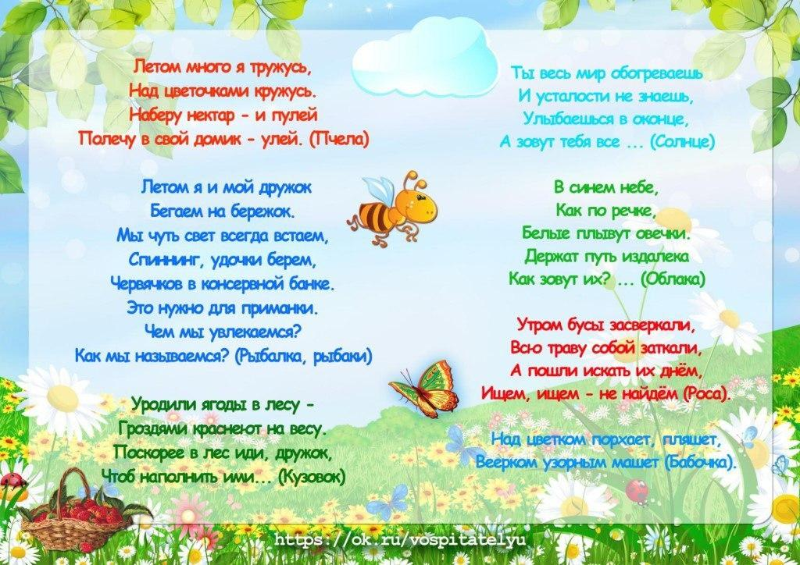

https://yandex.ru/search/?lr=16&text=%D0%B7%D0%B0%D0%B3%D0%B0%D0%B4%D0%BA%D0%B8%20%D0%BB%D0%B5%D1%82%D0%BE

https://yandex.ru/images/search?text=%D0%B7%D0%B0%D0%B3%D0%B0%D0%B4%D0%BA%D0%B8%20%D0%BB%D0%B5%D1%82%D0%BE&stype=image&lr=16&source=wiz

