Аппликация

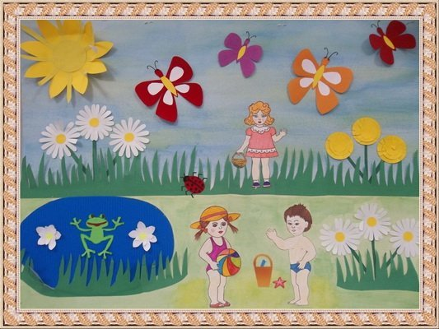

https://yandex.ru/images/search?text=%D0%B0%D0%BF%D0%BF%D0%BB%D0%B8%D0%BA%D0%B0%D1%86%D0%B8%D1%8F%20%D0%BB%D0%B5%D1%82%D0%BE%20%D0%BF%D0%BE%D0%B4%D0%B3%D0%BE%D1%82%D0%BE%D0%B2%D0%B8%D1%82%D0%B5%D0%BB%D1%8C%D0%BD%D0%B0%D1%8F%20%D0%B3%D1%80%D1%83%D0%BF%D0%BF%D0%B0&stype=image&lr=16&source=wiz

Рисование

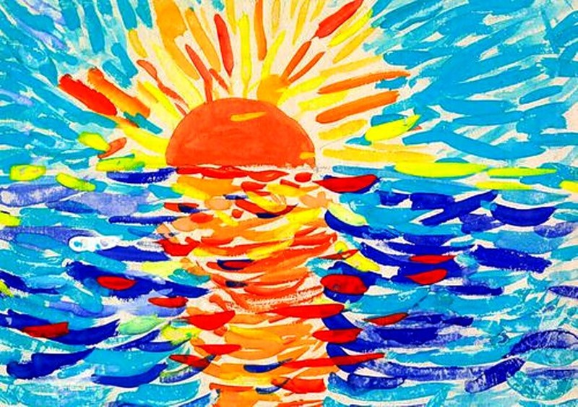

https://yandex.ru/images/search?text=%D1%80%D0%B8%D1%81%D0%BE%D0%B2%D0%B0%D0%BD%D0%B8%D0%B5%20%D0%BB%D0%B5%D1%82%D0%BE%20%D0%BF%D0%BE%D0%B4%D0%B3%D0%BE%D1%82%D0%BE%D0%B2%D0%B8%D1%82%D0%B5%D0%BB%D1%8C%D0%BD%D0%B0%D1%8F%20%D0%B3%D1%80%D1%83%D0%BF%D0%BF%D0%B0&stype=image&lr=16&source=wiz

Пластилинография

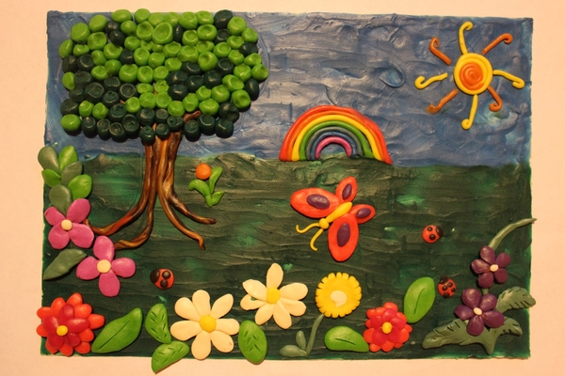

https://yandex.ru/images/search?text=%D0%BF%D0%BB%D0%B0%D1%81%D1%82%D0%B8%D0%BB%D0%B8%D0%BD%D0%BE%D0%B3%D1%80%D0%B0%D1%84%D0%B8%D1%8F%20%D0%BB%D0%B5%D1%82%D0%BE%20%D0%BF%D0%BE%D0%B4%D0%B3%D0%BE%D1%82%D0%BE%D0%B2%D0%B8%D1%82%D0%B5%D0%BB%D1%8C%D0%BD%D0%B0%D1%8F%20%D0%B3%D1%80%D1%83%D0%BF%D0%BF%D0%B0&stype=image&lr=16&source=wiz

